GEORGIA – 2020 GHED Validation

Overview of validation process [table is completed by WHO]
Date | Stage | Note to country
10/08/2020 | Data received
25/08/2020 | Initial validation | Please provide your comments in red after each question
03/09/2020 | Feedback received | Comments from IHAT in green
08/09/2020 | Further validation | Please provide your comments in blue
08/09/2020 | Feedback received | Comments from IHAT in yellow
14/09/2020 | Further validation | Please provide your comments in purple

Consistency check

- There are some consistency problems detected, what are described in points 4, 5 and 7.
Responses are reflected in points 4, 5 and 7 respectively.
Noted

Negative values/Atypical entries

- No negative values detected. One atypical entry is described in the metadata file, which is not actually an atypical entry, but thank you for describing it separately.

Revisions

- No revision has been submitted.

Growth rates

- Current health expenditure increased by 104% (2,989mln NCU) in 2018 (at current prices). This is an outstanding increase which needs a very good explanation (e.g. changes due to policy reforms or increases/decreases in prices or volumes or changes in your accounting practice) and revision of time series. Otherwise data cannot be accepted and published.

The source of this increase is OOP reported as a co-payment for in-patient care. We have detected this as an erroneous reporting by the single payer and warned correspondingly in the email message when submitted the ptstudy. We planned consultations with respective health officials to correct the primary data, which would result in a reduction of HF.3.2.1 by 2 billion.
After the update HF321 declined to 187 million GEL, while HF31 is 1325 million GEL, so the total OOP amounts to 1512 million GEL.
Thank you. Using the updated data, we register that CHE increased only 10.3% or 295 mnNCU. We assume that if you update the NGO data for previous years, the growth will be even more modest.

- We would appreciate your verification and clarification also for some other changes:

- FS63. We observe Other revenues from corporations n.e.c. are registered for the first time. Could you kindly explain what changes happened in Georgian health care system?
FS.6.3. Other revenues from NPISH n.e.c. are indeed added for the first time. During the extensive data collection process for HA 2018, we have identified a new source for FS63 -- a study carried out by GeoStat. The same data source can be used to amend data for previous years.
- Could you kindly provide this NPISH data for all available previous years?
NPISH data from previous years is available and can be added to previous year NHA reports. The plan is to do so while re-calculating previous years based the new methodology
When do you plan to update the time series? Please note that we close our database for updating on September 30th, so we will publish data for the country on the GHED, which was submitted before that.

NPISH data for previous years will be add for next year.

- Also, could you confirm that some part of expenditures classified under FS63 is not Direct foreign transfers (FS7), which is missing in the current study? Also please note that usually financing sources for development agencies is FS7.
We checked again with Geostat and the source of costs under FS63 code is not international transfers. However, perhaps the research methodology needs to be further explored.
We encourage you to investigate this issue more deeply in the future to be sure on the quality of the data.

According to the Geostat data, FS63 code is not international transfers.

- HF22. NPISH financing schemes (including development agencies) expenditures increase 438% (from 47.5 mlnNCU in 2017 to 255.64mln NCU in 2018.
HF.2.2. in previous years included only schemes funded from external sources (47.5 as noted); since for 2018, we have identified and used a new source for this data (see comment for 5.a), now the figure captures schemes funding from domestic sources as well.
Could you kindly provide updated NPISH (HF22) data for all available previous years?

NPISH data from previous years is available and can be added to previous year NHA reports. The plan is to do so while re-calculating previous years based the new methodology
When do you plan to update the time series? Please note that we close our database for updating on September 30th, so the country will have the data published on the GHED, which was submitted before that.

NPISH data for previous years will be add for next year.

- HF3. Household out-of-pocket payment increased 170%, accounting for 72% of CHE. Thus, Georgia occupies one of the leading positions in the share of OOP in EURO region.
Please see the response to issue #4.
Thank you for updating the data. After submission of corrected data OOPs expenditure (HF3) decreased -4% compare to 2017 year. Do you know the reason of this decrease?
Compared to 2017, government spending increased by 10%, thus reducing out-of-pocket payments
Noted

Methodological and compilation issues
- Compilation issues
  - FS11xHF21. Could you kindly explain what did you classify under this cross? Please note that subsidies for compulsory or voluntary health insurance schemes (managed by private insurance companies) classified as FS13 (SHA pg. 200).
Several government agencies (line ministries such as the Ministry of Defence, the Ministry of Justice and the Ministry of Internal Affairs) purchase private health insurance for their employees with the funding from the state budget. FS11xHF2112 classifies this expenditure that has been used historically for many years.
Thank you for the explanation. From your answer we understand that this scheme is not mandatory (only some ministries purchase private health insurance policy for their employees, and it is not regulated by any low), and therefore it is HF21 as you have indicated.
However, in this case it cannot be FS11 Internal transfers and grants between government institutions, since this category includes only internal transfers within central and regional/local governments, and grants from central regional/local governments.
As it is voluntary prepayment it should be FS52 (Voluntary prepayment). However, FS.RI should show Government.

This issue was also discussed at the Minsk meeting, where we have agreed to retain FS11 x HF21 coding for this expenditure category, given that it has been used historically over the years. Perhaps it is better to discuss this issue at the next meeting.
Noted. This issue should be discussed indeed. Could you kindly add this issue in the metadata file as atypical entry in section II.3. Atypical entries so far and resubmit the metadata file?

Added in section II.3.

  - We try to understand better the Georgia health care system:
    - HP1xHC64. Could you kindly explain what Healthy condition monitoring programmes hospitals provide and for what type of patients?
This includes antenatal care monitoring and medical check-up service for army recruits, which are often provided by outpatient department of hospitals, as well as antenatal services provided by hospitals (e.g. maternity hospital outpatient department providing antenatal care). Respectively, patients covered with those services, would include pregnant women and males who qualify for mandatory army service.
Thank you for the explanation.

    - HP34xHC11. What kind of inpatient curative care services you report for Ambulatory health care centres?
We have double-checked HP coding of healthcare providers contracted by the single payer for inpatient care and corrected HP (from HP34 to HP1.x) whenever possible.
However, HP34 x HC11 combinations still remain in the HA that can be explained by two factors:
- Some healthcare providers registered as outpatient clinics (so called multi-profile “polyclinics” or general ambulatories in periphery) have capacity (and license) to provide a limited set of inpatient (emergency or planned) services. Therefore, in addition to the services as per their profile, these types of healthcare providers are paid by the single payer, and HC11 coding comes from case-based reimbursement of HP34 facilities for inpatient care.
Noted. Could you please add this case in metadata file in section II.3. Atypical entries?
Thank you

- Medical holdings, when a legal person with unique tax code owns and operates two or more different types of healthcare facilities is a common phenomenon in Georgia. Unfortunately, no facility specific unique identifier has been used by the single payer or other public purchasers, and it becomes very difficult to separate outpatient clinics from hospitals with common owner when payments are made to the legal person. This issue is on the Ministry’s radar and presumably the data management and coding of healthcare providers will be streamlined.
We understand that depending on health information system sometimes it is difficult to have required granularity of the data. However, we try to understand why you do not classified facilities as hospitals (HP1) when you cannot separate outpatient clinics from hospitals?
We cannot change manually HP codes in the case-based datasets with millions of records unless the issues are sorted out in a systematic manner (as described above).
We invite you to work on this problem in the next future. Could you also, please add this information in section III.3. Current state of ICHA-HP implementation saying that there are some hospitals mapped under HP34?

Added in section III.3.

    - HP34xHC511. Prescribed medicines are provided by Ambulatory health care centres. Could you kindly give an explanation about this situation in your health care system?
Ambulatory healthcare centres are used to distribute some prescription drugs procured for specific groups of population from central budget. This includes factors for patients with haemophilia, treatment for Hep C, morphine for palliative care patients (for home-based administration) and few other types of drugs.
Thank you for clarification.

    - HP3necxHC62. What type of the health care facilities do you classify under this category?
Vaccines (HC.6.2.) is distributed via different healthcare providers on the whole spectrum of HP3. The data provided does not allow us linking expenditures for vaccine procurement to consumption at specific sub-types of outpatient providers. Quality of data might improve in the following years.
Noted.

    - HP42xHC11, HC133, HC43. Could you provide some information why Medical and diagnostic laboratories provide such services?
Five healthcare facilities with a primary profile of diagnostic services have licenses for a limited types of inpatient care. The single payer paid them for inpatient care in 2018 that is recorded in the case-based dataset and coded respectively in HA 2018.
All these facilities provide a wide range of outpatient care (mostly specialised) in addition to the diagnostic (laboratory) services.
Noted. Could you kindly describe this case in metadata file in section II.3. Atypical entries?
Could you kindly add this issue in the metadata file as atypical entry in section II.3. Atypical entries and resubmit the metadata file?

Added in section II.3.

HP42 x HC43 was a mistake – it reflected the consumption of transportation services commissioned by the Ministry of Justice (for prisoners). It was recoded to HP41 x HC43
Thank you.

    - HP6xHC133 and HC71. Kindly explain what kind of Specialised outpatient curative care services are provided by Providers of preventive care? Also, we are keen to know what admin services are provided by this type of facilities.
HP6xHC71 codes administrative services provided by the National Center For Diseases Control and Public Health, which is a national body responsible for planning and provision of public health services focused on surveillance and prevention.
HP6xHC133 this includes surgical services provided by a preventive medicine (healthcare) providers in conjunction with rabis vaccine. Those surgical services are classified as 1.3.3.1 Emergency specialised outpatient curative care.
Thank you for explanation.

  - HP72. There are some expenditures registered under Social health insurance agencies. In the metadata file you reported that there is no Social health insurance in Georgia. Also, Social health insurance schemes (HF121) is not registered in your data. Could you explain this phenomenon?

It was mistake. Recoded to HP71.
Thank you

  - HP82xHC14, HC63 and HC71. Please clarify what kind of facilities are classified under All Other industries as secondary providers of health care and what kind Home-based curative care, Early disease detection programmes and Governance and Health system administration they provide?

HP82 x HC14 includes home-based curative care services delivered by the mobile teams in several municipalities by non-governmental organisations contracted by local authorities.
Could you kindly explain what is “mobile teams” and what is their main activity?

“Mobile teams” in Georgian context, refers generally to a multi-disciplinary team of specialists or nurses, which travels to the place of residence of a patient and provides care there. It can include palliative care, mental health care, assistance to elderly or disabled patients, etc.
Under the HP.8.2 usually secondary providers are classified. From your explanation it seems for us that “mobile teams” primary activity is health care service and they are Providers of home health care services (HP35). Could you comment on that?

Added in section II.3.

HP82 x HC63 was recoded to HC654nec for consistency reasons (as per the GFATM to SHA crosswalk) and reflected services provided by non-governmental organisation for HIV detection among MSM. However, we think HC63 is still applicable as in case of tuberculosis case detection.
    - Could you kindly explain what kind of health care provider you code under HP82 in this case?
Services provided by NGOs to the key populations encompass different types of care listed in “GFAMT to SHA crosswalk_Finalized.xlsx” file (e.g. tab HIF, column “C”, rows 54,56,65, 67, 71, 88, 90).
- Case detection and contact tracing
- Referrals for testing (or sometimes rapid testing with a referral for confirmation)
- Counselling (Pre and post-test)
- Intensified case finding for TB
- (HIV status) Disclosure support.
Noted. Unfortunately, we could not open the crosswalk table.

    - Also, could you kindly explain what providers under HP82 provide administrative services (HC71)?
HP82xHC71 was a mistake in the original version, and corrected it in the submitted version. Please see the HA report fragment below:
Thank you

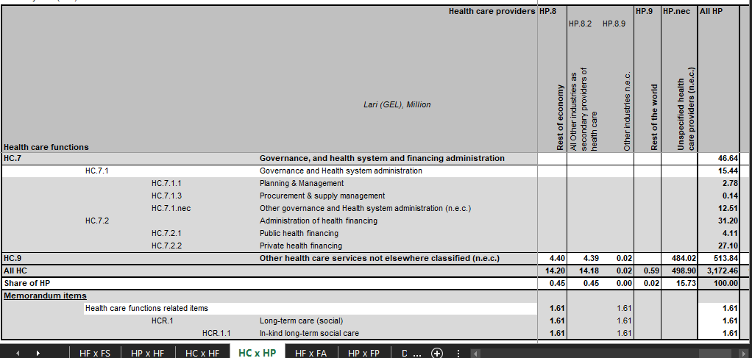

  - HP89. Could you kindly describe what kind of facilities you classified under this category? Please not that HP89 is used in very rare cases.
After revision of HP89 codes only one service provider remains in HA 2018: a company providing a waste management service to the medical department of the penitentiary system. The Ministry of Justice purchased this service and is included in the respective section of the state budget.
Waste management service is not health care service in a meaning of final consumption. So, provision of this service will be intermediate consumption and should be mapped as factor of provision in the boundaries of each health care service and under the particular health care provider who uses this non-health care services to provide own health care services.
So, your mapping will be like something the following:
FS11(Government) – HF11 (MoJ) – HP11 (for example) – HC11(for example) – FP33nec (other non-health care services)
Kindly remap this expenditure and resubmit the study.
Ministry of Justice if FA and it purchases services from two providers: a public entity for medical services and a private entity for medical waste management.
In both cases the consumption is final. In the books of medical service provider there is no such expenditure on medical waste management. to code with FP33nec. If we consider expenditures on medical waste management as a “factor of provision” then we have to treat the Ministry of Justice (that’s where this payment is registered in the accounting books) as a healthcare provider. But the Ministry of Justice is just a FA.
Final consumption means that households use health care services or/and purchase health care goods. Households do not consume medical waste management. There are health care providers who use this service to provide health care services, therefore it is intermediate consumption.

Medical waste management is a “factor of provision” and Ministry of Justice is not a health care provider, but HF and FA. Facilities who provide health care services and use medical waste management service should be mapped as health care provides.
Please correct the study and resubmit it.

Added in section II.3.

  - HC2 and HC3xDIS. Kindly check these crosses. Many of them seems not logical.
The mistakes, or inconsistencies across HC2/HC3 and DIS are caused by the fact that the healthcare providers were paid for HC2 or HC3 functions (through respective “vertical health program”, or universal health program), and they report independently on medical statistics (ICD10) codes. When these two datasets (payments linked to HC) and medical statistics (ICD10 > DIS) are combined for each such healthcare provider, the HCxDIS combinations are observes that seem suspicious. We tried to minimize such combinations to the extent possible.
Noted.

  - HC132xDIS. Also, kindly check these crosses. Here is also a lot of mistakes.
The same as above. As to dental clinics/services: many healthcare providers provide non-profiling care – for instance, a private business can be registered as dental clinic, but can have offices of specialists, various diagnostic services, and report non-dental diagnosis for medical statistics. We manually recoded to HC123 x DIS49.
We understand that dental care provides (HP32) can provide other services than dental care (HC132). However, we do not understand how other diseases, except oral diseases (DIS49), can be treated with dental care service? We kindly ask you to review the data and resubmit the study.
Illogical pairs HC x DIS originate from combining two sources for estimating OOP expenditures: the household budget survey (for actual amounts) and Health Expenditure and Utilisation Studies (for distributing OOP health expenditures by HC and DIS). We corrected the algorithm of merging these two datasets and eliminated illogical pairs as advised.
There is still a cross HC132xDISnec. Could you kindly explain what do you map under this combination?

Added in section II.3.

  - DIS6xHC13, HC1nec, HC4, HC5 and HC9: Please clarify what you classified under these crosses?
DIS6 code was revised:
- It is not crossed with HC5 any more. Noted
- DIS6 remains in the following instances:
- As reported by households: Could you kindly explain what health care system administrative issues (DIS6) are mapped under curative care and purchases by households?
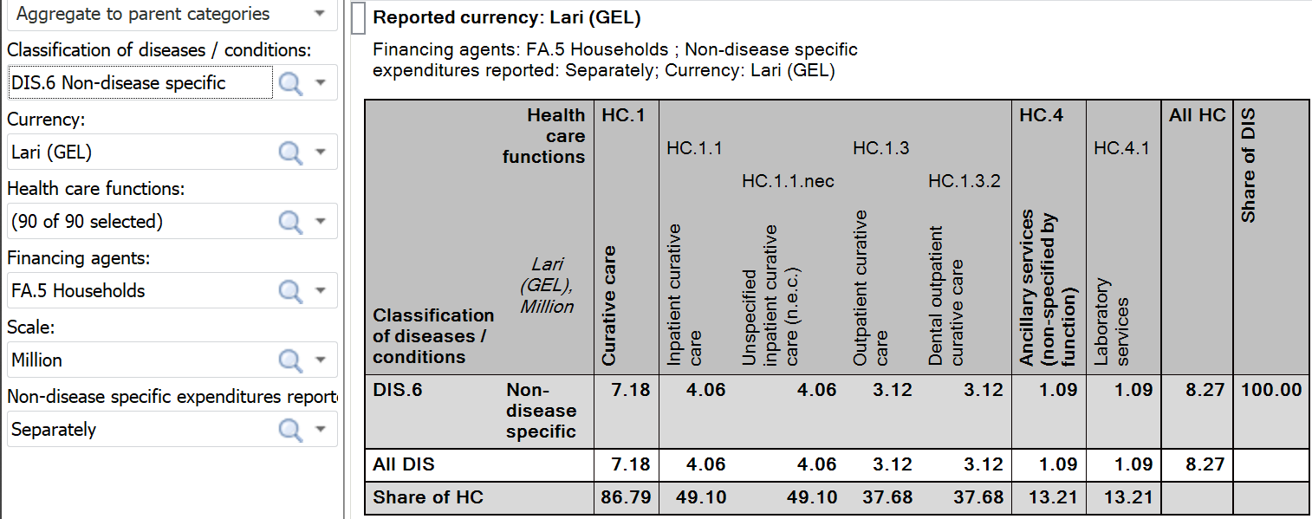
Corrected.
Thank you.
- In relation to expenditures on the wastage management services purchased by the Ministry of Justice (for healthcare in prisons)
Please refer to Q.6e and remap diseases according provided service or reclassify as Unspecified diseases/conditions (DIS.nec), if you do not know what disease were treated.
Corrected.
Thank you

- The expenditures on existence/maintenance of several healthcare providers in conflict affected regions – as per the Government decree, the payment to different types of inpatient and outpatient care providers is not related to any disease and was coded as HP6
The provision of each service is related to some disease. The main concept of SHA2011 is final consumption of provided services which treat diseases. The starting point cannot be resources distribution. However, if you cannot provide disease distribution please code this expenditure as Unspecified diseases/conditions (DIS.nec). DIS6 is strictly reserved for administration purpose.
We recoded the scheme to HC7.nec x DIS6. These healthcare providers are the only administrative units that represent the Georgian state in the occupied territories by implementing some administrative functions in health. Therefore, irrespective of their profile, they serve healthcare administration function as well not related to any diseases.
Keeping this expenditure separate from any other public expenditures is important even if it creates unusual combination of the codes (HP1 x HC7 x DIS6). We added it to metadata file in section II.3. Atypical entries.
Sorry, we cannot find this issue in section II.3. Atypical entries. Could you send the metadata file by email to ensure that we use the correct file after the next updating?

Has already been added to the section II.3 (in red)

7. Missing variables:

- FS7. There is FS7 reported all years 2000-2017. Also, OECD DAC reports FS7 for Georgia. In addition, UNFPA and GAVI report disbursements for 2018 year. Both UNFPA and GAVI data are missing in the study. Please update your data?
Expenditures for GAVI will be added in the revised version; as of UNFPA expenditures, data received from UNFPA was of a low quality and did not include items of health consumption.
Looking forward for getting data with the next round of data submission.

- Therefore, HC62xFS7 is missing, since GAVI data is missing. Please update your data.
Gavi was added and is coded as FSRI.1.5.2.7 x FS2 x HF1.1.1 x FA1.1.1.1
Could you kindly explain why Gavi is mapped as FS2 and not FS7? Does not Gavi distribute resources and vaccines directly to the system?
As discussed and agreed at the sub-regional meeting in Minsk, Gavi or GFATM supported government programs/policies can be coded as FS.2 > HF.1.1.1 > HF>1.x or FS.7.1.2|7.2.1.2 > HF.1.1.1>FA.1.1.1.x. We opted for the first option because it Gavi support contributes to the implementation of the government policy (which is mandatory to finance). The financing scheme for the policy implementation is HF.1.1.1, which is mostly financed from FS1 but some revenues come to the Government via as FS2. There is no direct transaction between Gavi and health care providers.
Direct foreign transfers (FS7) can also go to MoH or other government organisations, it is not only transaction to health care providers.
The main difference between (Transfers distributed by government from foreign origin) FS2 and direct foreign transfers (FS7) is that under FS2 the government decides if resources should go to e.g. health or something else or how thy should be distributed where direct transfers mean that it is already decided by source that resources goes to health and on what circumstance. The GAVI vaccines is a good example of FS7.

Added in section IV.1.

- FS14. there is no data for Other transfers from government domestic revenue for NGO. Could you confirm that these revenues are not a case of Georgia?
FS.1.4. was not used in previous years as well. Transfer of public funds to health service providers in Georgia is done via procurement mechanism. We do not have a systematic way to capture any transfers to NGO, as a specific type of providers.
Noted.

- HP1xHC131. Could you confirm that hospitals do not provide General outpatient curative care in Georgia?
Hospitals do provide general outpatient curative care but there is no data on this specific consumptions:
- The government schemes channel money for specialised outpatient care provided by hospitals (but pay for general outpatient care provided by ambulatories).
- Households pay OOP for general outpatient care provided by hospitals as well, however expenditures on this specific consumption (general outpatient care x hospitals) cannot be extracted from the Living Standard Measurement Studies conducted by GeoStat.
Noted. Could you kindly register this HC131 underestimation case in the metadata file in section III.2. Current state of ICHA-HC implementation? The Ministry continues to work on the full implementation of the classification
We are glad to hear that you have plans to improve the data. However, we kindly ask you to fill in the metadata for this year submission. Next year you will have an opportunity to update the metadata file regarding to a new data submission.

Added in section III.2.

- HP2xHC3. Could you confirm that Residential long-term care facilities do not provide Long-term care (health) in Georgia? Kindly explain what you classify under this type of facilities?
HC3 includes hospice-based care, and long-term mental health care; long-term mental healthcare is delivered by mental health hospitals and there are no designated residential facilities; as of long-term care for terminally ill patients there are few hospices which deliver those services.
Could you specify under what category of HP you code such hospices?
HC3.1 x HP11; HP12; HP13
HC3.2 x HP11; HP3.3; HP3.4; HP3.4.9
You indicated that LTC is delivered by general hospitals (HP11), mental health hospitals (HP12), Specialised hospitals (HP13), Other health care practitioners (HP33) and Ambulatory health care centres (HP34). This is correct, all these facilities can provide LTC.
However, we wonder where you map these few hospices what by definition are not anything from about mentioned list?

We could not find data for these few hospices provide LTC services in 2018

- DIS23. There are no expenditures for programs that manage contraception and family planning registered. We assume that it should be at least government expenditure for program administration. Also, UNFPA reports some disbursements for Georgia.
Consumption of family planning services and contraception commodities occur in the country; although existing quality of the data does not allow to disaggregation of this consumption.
In addition, at this stage, UNFPA data is not included in the analysis given that information provided is of a low quality and items contained in the reporting spending categories where beyond healthcare consumption.
Noted. Could you kindly register this issue in the metadata file in section IV.4. Current state of DIS implementation? The Ministry continues to work on the full implementation of the classification
We encourage you to work on the development of this item in the future, since it become more and more vital for development organizations.
Thank you

Please correct and resubmit the studies and time series. Thank you!

